THREE DAY LOW PUTTS
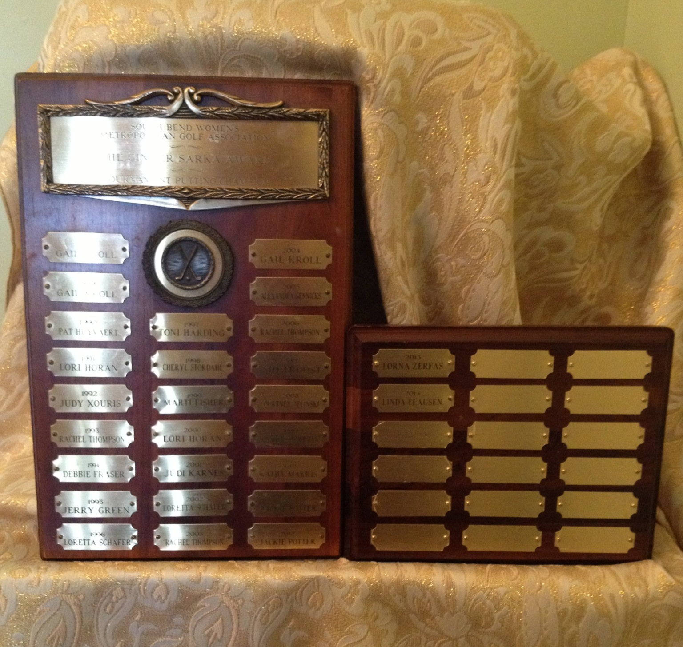
2027
2026
2025
2024
2023
2022
2021
2020
2019. Rachel Thompson
2018 Rachel Thompson
2017 Lorna Zerfas
2016 Rachel Thompson
2015 Tamara Finn
2014 Linda Clausen
2013 Lorna Zefas
2012 Jackie Potter
2011 Jackie Potter
2010 Kathy Makris
2009 Jennifer Zimmerman
2008 Courtney Jelinski
2007 Sid Troost
2006 Rachel Thompson
2005 Alexandra Gennicks
2004 Gail Kroll
2003 Rachel Thompson
2002 Loretta Schafer
2001 Judi Karnes
2000 Lori Horan
1999 Marti Fisher
1998 Cheryl Stordahl
1997 Toni Harding
1996 Loretta Schafer
1995 Jerry Green
1994 Debbie Fraser
1993 Rachel Thompson
1992 Judy Xouris
1991 Lori Horan
1990 Pat Huyvaert
1989 Gail Kroll
1988 Gail Kroll

Ginger Sarka Putting Legacy Trophy

