RUNNER – UP
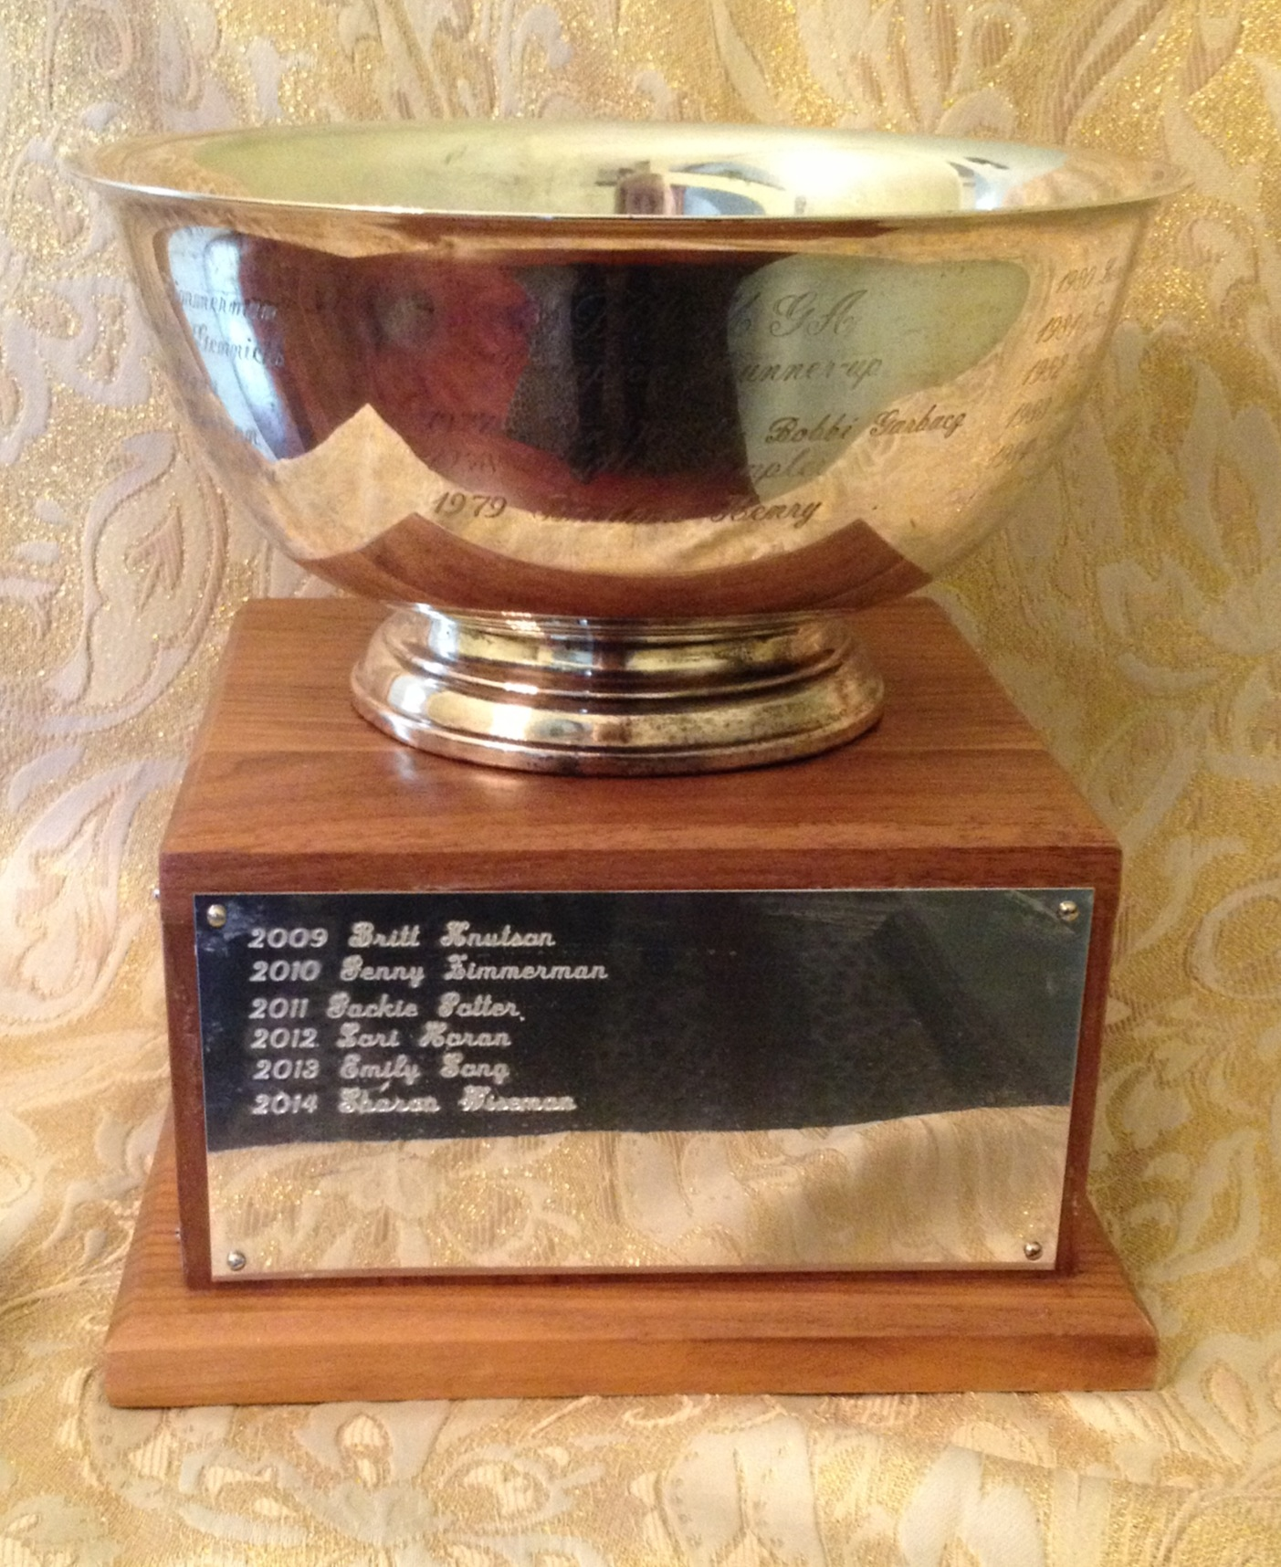
Florrie Fischgrund Legacy Trophy

2027
2026
2025
2024
2023
2022
2021
2020
2019 Grace Szklarek
2018 Rachel Thompson
2017 Andi Sandler
2016 Jenny Zimmerman
2015 Andi Sandler
2014 Sharon Wiseman
2013 Emily Song
2012 Lori Horan
2011 Jackie Potter
2010 Jenny Zimmerman
2009 Britt Knutson
2008 Britt Knutson
2007 Britt Knutson
2006 Lori Horan
2005 Alexandra Gennicks
2004 Jennifer Zimmerman
2003 Jennifer Zimmerman
2002 Jennifer Zimmerman
2001 Gail Kroll
2000 Jenny Zimmerman
1999 Barbara Henry
1998 Rachel Thompson
1997 Loretta Schafer
1996 Brandi Blad
1995 Gail Kroll
1994 Kate Halizchak
1993 Gail Kroll
1992 Lori Horan
1991 Jennife Holczynski
1990 Jennifer Holczynski
1989 Lori Horan
1988 Alice Plain

1987 Glenda Krizman
1986 Gail Kroll
1985 Gail Kroll
1984 Barbara Henry
1983 Barbara Henry
1982 Gail Kroll
1981 Bobbi Garbacz
1980 Lori Heiden
1979 Barb Henry
1978 Phyllis Wampler
1977 Jean Ward-Bobbi Garbacz

